|  |  |  |
| --- | --- | --- |
| Collège  Class of 6ème | Geocaching – Team 1 | Physics and Chemistry  Activity in DNL |

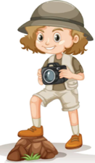Names: ………………………………………………………………………………………………………………………………………………………………

Hello team 1!

* Go and find **“Cache” n°1** (in the schoolyard of the “collège”)
* You start in the Science Lab (“**Start**”),
* When you find the “cache”, write down your research and your answer on this activity paper.

***Map of the “caches” (created by the class of Seconde …..)***

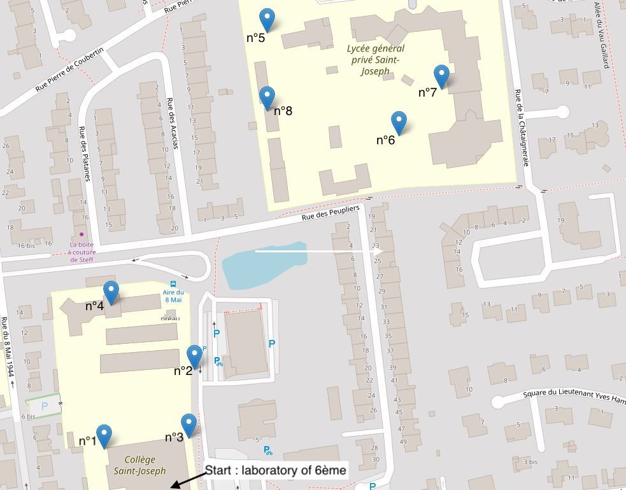

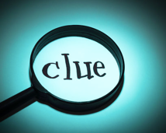

***A clue to help you to find the “cache”: “Look into the bushes!”***

You found the “cache”? Great!

Write down the question inside it.

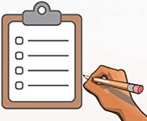

Question:

…………………………………………………………………………………………………………………………………………………………………………………………………………………………………………………………………………………………………………………………………………………………….

Solution:

…………………………………………………………………………………………………………………………………………………………………………………………………………………………………………………………………………………………………………………………………………………………….

…………………………………………………………………………………………………………………………………………………………………………….

The clue for the final “mystery word” is:………………………….

(keep it carefully)



**Vocabulary to help you**

|  |  |  |  |
| --- | --- | --- | --- |
| **The verbs** | **The names** | **The adjectives, the comparative form, the superlative form** | **Questions** |
| **To travel** = voyager  **To speed** = accélérer  **To cover** (example : to cover 10 meters) = parcourir  **To devide by** = diviser par  **To be located** = être situé  **To find the cache** = trouver la cache | **The speed** = la vitesse  **The distance / A meter** = la distance / un mètre  **Meter per second** = mètre par seconde  **Kilometer per hour** = kilomètre par heure  **The time / A second** = la durée / une seconde  **Train station** = la gare  **The speed unit** = l’unité de la vitesse  **A point of interest** = un point d’intérêt  **Geocaching (treasure hunt)** = chasse au trésor  **A clue** = un indice | **Fast / slow** = rapide / lent  **Useful** = utile  **Less time / more time** = plus de temps / moins de temps  **Safe** = en sécurité  **A famous place** = un lieu connu  **In motion relative to** = en mouvement par rapport à  **Stationary relative to** = immobile par rapport à  **A straight motion** = un mouvement rectiligne  **A circular motion** = un mouvement circulaire | **How much time ….?** = combien de temps ?  **How speed / How fast ….?** = à quelle vitesse ?  **How high ….?** = A quelle hauteur ?  **How long …. ?** = quelle est la longueur ?  **In which country …?** = dans quel pays ?  **What is the name of ….?** = quel est le nom de … ?  **Can you calculate the speed ?** = peux-tu calculer la vitesse ? |