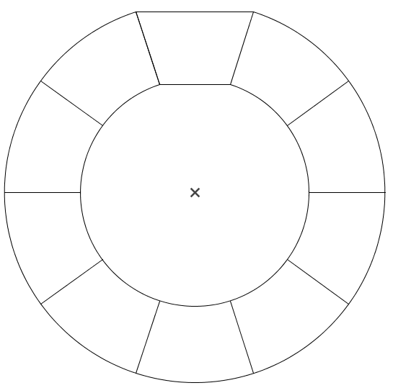
2(x + 4) =
x(5 – 3x) =
x(2x - 4) =

-4(x + 3) =
5(10 + 2x) =
Développer les expressions suivantes.

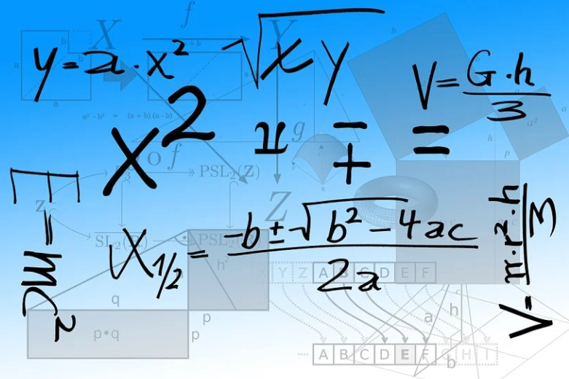
-6(3 - 2x) =
-4(-2 – 3x) =

3(2x - 4) =
3(2 – 7x) =

2x(3 + 5x) =

2x + 8
5x - 3x²
2x²- 4x

50 + 10x
-4x - 12
Solutions

-18 + 12x
8 + 12x

6x - 12
6- 21x

6x + 10x²

