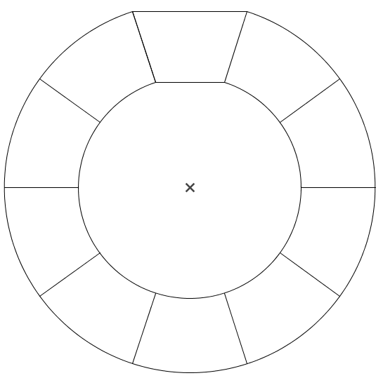
-6 - 8x =
5x -7 -4x -3=
-3x +3 + x =

15 +x -7 -x =
4x +3 + 5x =
Si possible, réduire
les expressions suivantes.

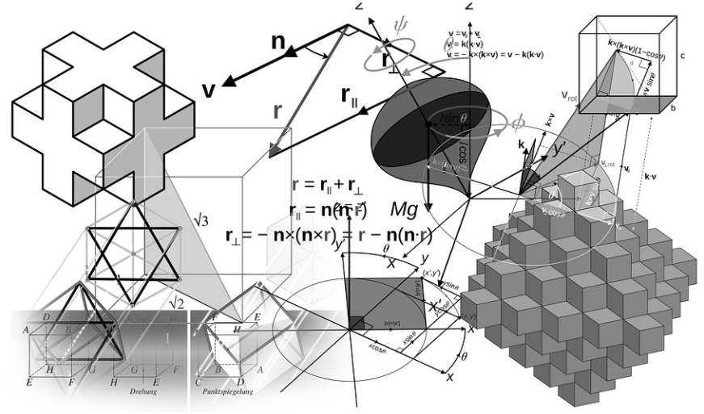
5 + 3x - 12 =
4 + 6x - 10 =

4 – 6x +3 +2x =
-3 -2x +3x +4 =

5 +2x +4x +12 =

-6 - 8x
x - 10
-2x + 3

9x + 3
8
Solutions

3x - 7
6x - 6

-4x + 7
x + 1

6x + 17

